Advanced Shell Simulation with Integrated OS Concepts

Group 4:
Abdul Rahim Aamir
Ebubechukwu Ohizu
Gaurab Karki
Rajiv Agrawal

An assignment submitted in partial fulfillment of the requirements for MSCE-631 as part of the degree, Master of Science
In
Cyber Engineering

School of Computing and Information Sciences
University of the Cumberlands
MSCE-630: Advanced Operating Systems
Dr. Primus Vekuh
March 28, 2026

Spring 2026

Basic Shell Implementation and Process Management
1. Process Management
Overview
The shell follows a classic Read-Eval-Print Loop (REPL) design. On each iteration it reads a line from stdin, hands it to the parser, dispatches to a built-in handler or launches an external process, and then returns to the prompt.
Foreground Processes
External commands that are not suffixed with & are run as foreground processes using subprocess.Popen. The REPL immediately calls process.wait(), which blocks until the child exits. During the wait, KeyboardInterrupt (Ctrl-C) is caught: the child is terminated and the shell returns to the prompt rather than exiting. This mimics the Unix model where the parent process waits (waitpid) for the child to terminate, preventing zombie processes.
Background Processes
When a command ends with &, it is launched with subprocess.Popen without blocking. The process's PID and metadata are stored in a job table (_jobs dict in process_manager.py). The shell immediately prints [job_id] pid and resumes the prompt.

myshell:/home$ sleep 10 &
[1] 19234
myshell:/home$

Job Table and Job Control
The _jobs dictionary acts as the job table, keyed by an auto-incrementing job ID. Each entry stores:
Field | Description
pid | OS process identifier
status | "Running" or "Done"
cmd | The original command string
process | The Popen object for the child

Three built-in commands interact with the table:
- Jobs: calls _reap_finished_jobs() to remove exited processes, then prints the remaining entries.
- fg [id]: pops the entry from the table, sends SIGCONT on Unix to resume a stopped process, then calls process.wait() to bring it to the foreground.
- bg [id]: sends SIGCONT on Unix to resume a stopped process without blocking the shell.

Zombie Reaping
_reap_finished_jobs() is called before every jobs, fg, and bg invocation. It iterates the table and removes entries where process.poll() returns a non-None exit code, which internally calls waitpid through Python's subprocess layer and prevents zombies from accumulating.

2. Error Handling
Command Not Found
If subprocess.Popen raises FileNotFoundError, the shell prints:
shell: command not found: <cmd>
and returns exit code 127, matching the POSIX convention.
Built-in Argument Errors
Every built-in validates its argument list before acting. Missing operands produce a usage hint:
shell: mkdir: missing operand
shell: cat: missing file operand
shell: kill: usage: kill <pid>
File-System Errors
All file-system operations (cd, ls, cat, mkdir, rmdir, rm, touch) wrap the OS call in a try/except block that catches FileNotFoundError, PermissionError, IsADirectoryError, and NotADirectoryError. Each prints a descriptive message prefixed with shell: <cmd>:.
Example:
shell: cd: /root: Permission denied
shell: rm: cannot remove 'ghost.txt': No such file or directory
Invalid PID for kill
do_kill first parses the argument as an integer; a non-numeric value raises ValueError and prints an "invalid pid" message. ProcessLookupError covers non-existent PIDs, and PermissionError covers insufficient privileges.
Parse Errors
shlex.split raises ValueError on unclosed quotes. The parser catches this and prints shell: parse error: <detail>, then returns None so the REPL skips execution for that line.
Signals at the Prompt
- Ctrl-C (SIGINT): caught in the REPL's except KeyboardInterrupt block - prints a newline and loops back to the prompt. The shell does not exit.
- Ctrl-D (EOF): caught as EOFError - the shell prints a newline and exits cleanly.

3. Challenges and Improvements
Challenge 1 — Cross-Platform Signal Handling
Unix job control relies on SIGCONT and SIGSTOP to suspend and resume processes. Windows does not support these signals. The shell detects sys.platform and skips SIGCONT on Windows, meaning that bg on Windows marks the job as running but cannot actually un-stop a suspended child. A future improvement would be to use Windows Job Objects or a platform-specific threading approach for equivalent behaviour.
Challenge 2 — Background I/O
Background processes currently share stdout/stderr with the shell. This means a background process can interleave its output with the shell prompt. A production shell would either redirect background output to a buffer or implement a proper terminal driver (PTY) to separate the streams. For this deliverable the behaviour is acceptable for demonstration purposes.
Challenge 3 — Exit Code Propagation
Python's built-in exit name conflicts with our do_exit built-in. The solution was to register the handler under the string key "exit" using the _register decorator while keeping the function named do_exit. The REPL lets SystemExit propagate through a bare raise, which is then caught in main() where sys.exit() is called with the correct code.
Possible Improvements
- Tab completion using readline for command and filename completion.
- Command history persisted to ~/.myshell_history.
- Redirections (>, >>, <) for file I/O, a natural next step before pipes.
- Signal forwarding: route SIGINT from the prompt to the foreground child group rather than just terminating the child, to match bash behaviour more closely.

4. Screenshots
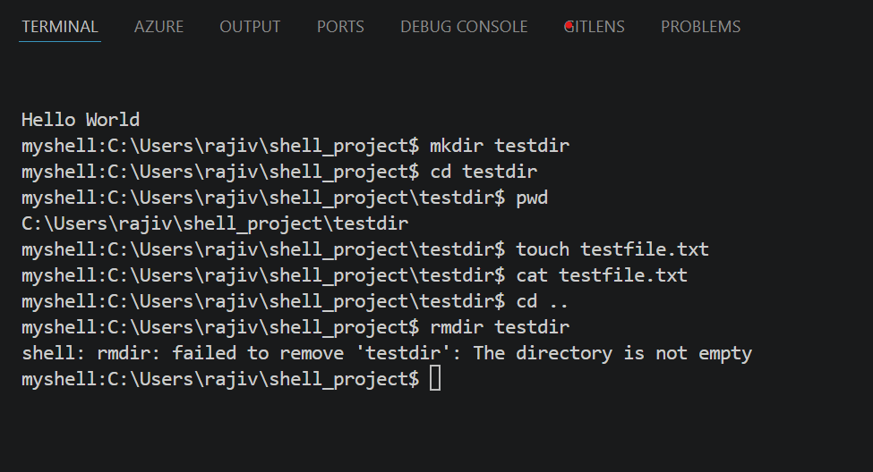
Figure 1: Basic Shell Implementation
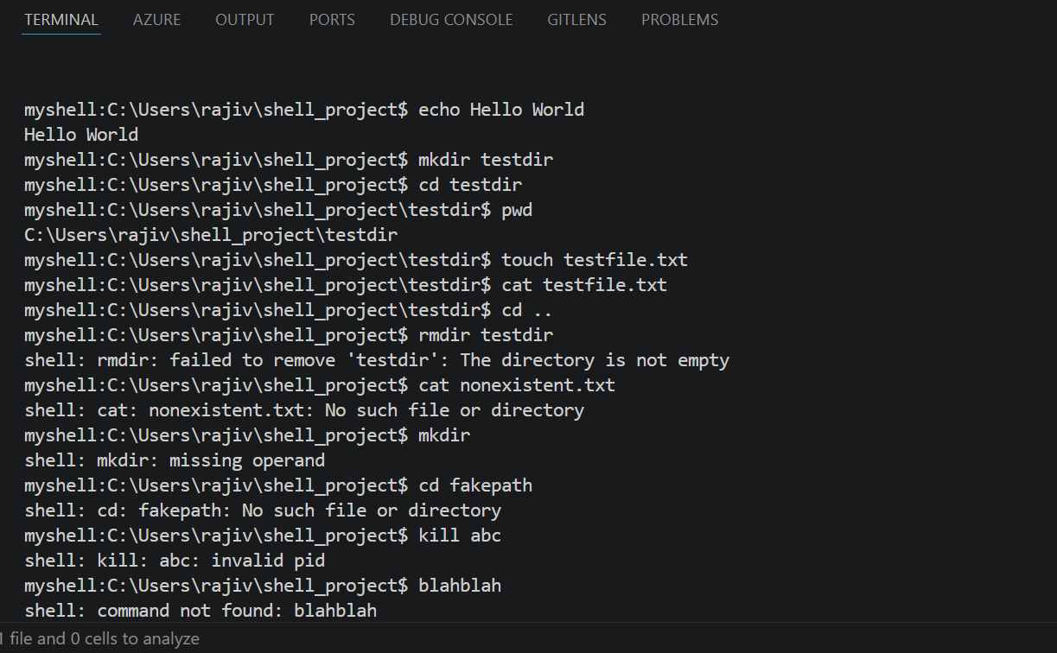
Figure 2: Basic shell implementation cont.

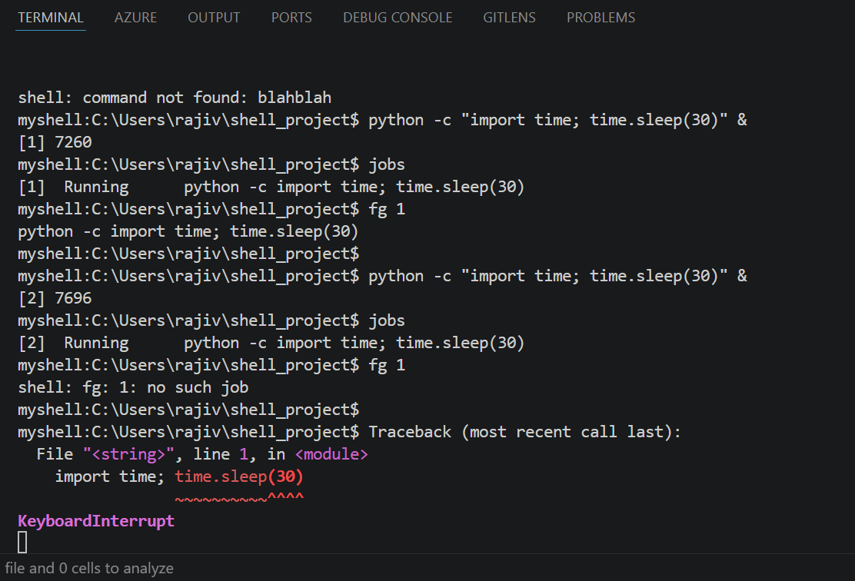
Figure 3: Process Management


University of the Cumberlands
School of Computing and Information Sciences

Certification of Authorship
Submitted to: Dr. Primus Vekuh
Course: MSCE-630
Students’ Name: Abdul Rahim Aamir, Ebubechukwu Ohizu, Gaurub Karki, Rajiv Agrawal
Date of Submission: 03/28/2026
Purpose and Title of Submission: Basic Shell Implementation and Process Management

Certification of Authorship: I hereby certify that I am the author of this document and that any assistance I received in its preparation is fully acknowledged and disclosed in the document. I have also cited all sources from which I obtained data, ideas, or words that are copied directly or paraphrased in the document. Sources are properly credited according to accepted standards for professional publications. I also certify that this paper was prepared by Group 4 for this purpose.

